|  |
| --- |
| Computer Language Coding Concepts |

## Command Calls in a Command Definition in a Diagram

This article demonstrates a situation of command objects.

This article illustrates how command calls in a command definition look in a diagram.

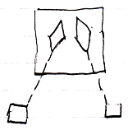

The large square is the parent command definition. The diamonds inside the parent command are two command calls. The diamonds are connected to squares with dashed lines. This makes those squares the command calls’ command definitions.